THE AFRICAN TIMES/USA

The African Times/USA is an influential global pan-African media organization and a member of the US Black Press. Founded in 1989 with its operation offices in the second largest media market in America, Los Angeles, California, it is also the media of choice for African communities (including the black diaspora) in the United States and Canada and serves news, features, and information to its readership and followership in the US and around the world.

Audience Reach | 1.3 million Combined Monthly Impressions ( Organic - Google, Social Media, Newsletter)
Audience Engagement | 588,000 (45.23% ENGAGEMENT RATE)
Highest Sponsored Reach | 12,000,000 (MONTHLY)
Website Link | www.theafricantimes.com
Facebook Link | https://web.facebook.com/theafricantimesusa/  With 107,300 Page Likes and 113,600 followers on Facebook (Source: Facebook Analytics)
Newsletter | 85,750 sent weekly.

Newsletter Marketing

We send 85,750 newsletter every week with a Consistent Open Rate of 47% and a Click Through Rate (CTR) of 21% while Email Deliverability Rate is 99%. Our Email Subscribers have known us for years as we build our email list by carefully collecting emails of a target demography since the last 20 years and counting.

Source: Email Service Provider (ESP) - DRIP Analytics

Website Analytics

We record 334.4k unique visitors with a bounce rate of 24%, an average session duration of 11 minutes. The average page views per sessions is 3. Click Through Rate (CTR) on the website is 13% with higher mobile visitors than desktop visitors in a 62-38% ratio. Our major source of traffic are: Organic search, direct traffic, referral traffic, search engine marketing and social media with majority of our website visitors coming from the United States of America and Africa.

Source: Google Analytics

As the media of choice for Africa in the United States, The African Times/USA has readership and followership from the White House, the US Congress, the United Nations and such other high profile bodies both in Africa and the US.
The African Times/USA has been honored by various government and private sector organization both in the US and Africa, including the City of Los Angeles

THESE VALUES HAVE GUIDED US ALL THESE YEARS:
INNOVATION, EXPERIENCE AND RESULTS
34 years is not 34 days

ADVERTISING OPTIONS

Banner Ads:

Banner ads are a highly visible and effective way to promote your brand or products to our diverse and engaged audience. They are strategically placed throughout our website, including the header, sidebar, and inline within articles, ensuring high visibility.

- Benefits
- Prominence: Banner ads are one of the first elements our audience sees, ensuring maximum exposure for your brand.
- Click-through Potential: Users can easily click on banner ads to visit your website or landing page.

2. Sponsored and Featured Articles/Stories:

Sponsored content provides an authentic and non-intrusive way to engage our audience with your brand. This is seamlessly integrated into our editorial content, offering a natural reading experience. This offer you the prime opportunity to tell your brand's story and engage our audience through informative and engaging contents. They are prominently displayed on our website and receive special attention from our readers.

- Benefits:
- Trust and Authenticity: Sponsored content is designed to blend with our editorial style, enhancing trust and authenticity. Featured articles allow you to provide valuable information, showcase expertise, and connect with our readers on a deeper level.
- Audience Relevance: Connect with our readers by providing content that is informative, valuable, and aligns with their interests.

Your featured article will be prominently displayed on our platforms and featured article section for maximum visibility.

- Exclusive Offers:

Exclusive offers are a powerful incentive to drive user engagement and conversions. They are tailored promotions or discounts that you can provide to our audience.

- Benefits:
Engagement: Exclusive offers create a sense of urgency and encourage our audience to take action.
Conversion: Drive sales, sign-ups, or other desired actions by offering exclusive deals to our readers.

Communication: We will collaborate with the client to effectively communicate these offers to our audience through banner ads, featured articles, and other channels, maximizing their impact.

Email Marketing: Engaging High and
Middle-Class Audiences

At The African Times/USA, we take great pride in our extensive reach and the quality of our engaged readership. We send out a substantial number of newsletters weekly, ensuring that your message reaches the right audience effectively. Here's how we maintain the excellence of our email subscriber base:

Weekly Newsletter Distribution:

We leverage the power of email marketing by sending out a whopping 85,750 newsletters each week. This frequency ensures that your brand's message is consistently communicated to our audience, maximizing your campaign's visibility and impact.

Audience Quality Assurance:

We understand the importance of ensuring that the client’s message reaches the right audience - individuals who are in the high or middle class income bracket. To guarantee the quality of our subscribers, we employ a meticulous process of audience collection and verification. Here's how we do it:

- Strategic Targeting: Our subscriber acquisition strategy is designed to attract individuals who fall into the high or middle class, ensuring that your campaigns resonate with the right socioeconomic groups.

- Data Verification: We employ stringent data verification processes to confirm the socioeconomic status of our subscribers. This includes analyzing various data points such as income, occupation, and education level.

- Segmentation: Our email subscriber base is carefully segmented based on socioeconomic criteria. This segmentation enables us to deliver tailored content and campaigns that align with the specific interests and preferences of our audience.

Campaign Flexibility:

While we send out newsletters weekly to maintain consistent engagement, we also recognize that campaigns may have different schedules. For this reason, we can adjust our email outreach strategy to bi-weekly for your campaigns, ensuring that your message aligns with your campaign timelines.

Material Preparation: Crafting Your Brand
Message

At The African Times/USA, we understand the significance of delivering a message that resonates with your target audience. We offer comprehensive support for material preparation, which includes the creation of textual content and engaging banner advertisements. Our goal is to ensure that the client’s brand message aligns seamlessly with our platform, creating a cohesive and impactful advertising experience.

Textual Content

Our experienced team of writers and content creators is ready to craft compelling textual content for sponsored and featured articles that not only captures the essence of your brand but also resonates with our readers. Here's how we can assist:

- Storytelling Expertise: We excel in telling stories that engage and educate. Let us help you narrate your brand's journey, values, and offerings in a way that captivates our audience.

- Alignment with Reader Interests: We will work closely with you to understand our audience's interests and preferences, ensuring that the content we create is not only informative but also relevant and engaging.

- Editorial Collaboration: Collaboration is key. Our editorial team will collaborate with the client’s brand to maintain the highest quality and ensure the content seamlessly integrates with our platform.

Banner Ad Creation:

Visual appeal is essential in grabbing the attention of our audience. Our design experts are skilled in creating eye-catching banner advertisements that convey your brand's message effectively.
- Client is responsible for providing banner designs.
- We can also help with banner designs if client is unable to provide one.

- Visually Engaging: We understand the importance of visual impact. Our designers will craft banners that not only look great but also align with the client’s brand identity. In cases where clients supply our team with their creative, we can collaborate with them to ensure that designs are consistent with the goals.

- Strategic Placement: Whether you have specific banner ad placements in mind or need guidance, we will oversee the most strategic locations on our platform for maximum visibility.

Consistency with Branding: Your brand's identity is paramount. The design elements, colors, and messaging in the banners must align harmoniously with the client’s brand's identity.

Collaboration for Success:

Collaboration is at the heart of our material preparation process. We believe that your input and vision are invaluable. When clients partner with us, you are not just a client; you are a valued collaborator in creating content that drives results.

COMPETITIVE ADVANTAGE

1 | Access to different Diaspora communities, Tourism boards and immigrant organizations in the US
2 | An email database of 85,750 Africans living in America collected over a 20-year period has been carefully selected to ensure conversions. THIS IS OUR BIGGEST MARKETING ASSET
3 | Exclusive promotion of brand partner’s offer to our travel and tourism email list

CLIENT LIST INCLUDE (AND NOT LIMITED TO):

1 | Ethiopian Airlines
2 | VERTEX PHARMACEUTICALS
3 | UNITED STATES POSTAL SERVICES
4 | VISA AFRICA
5 | SEYCHELLES TOURISM BOARD
6 | AFRICA TOURISM ASSOCIATION (ATA)
7 | WESTERN UNION
8 | SOUTH AFRICAN WINES
9 | Turkish Airlines
10. Royal Air Maroc
11. South African Tourism Board

CAMPAIGN SUCCESS STORIES

CASE STUDY ONE
NAME OF CLIENT | VERTEX PHARMACEUTICAL USA
Goal of Campaign | Get Subscribers for their New Innovation
Target Audience | Black Community in the USA and other people of color.
Strategy Applied | Publication of a Three (3) Part Research Work on Sickle Cell Disease (as it affects People of Color) on our website and promotion of contents on our social media.
Platforms Used for Promotion | Website, Newsletter and Facebook
Duration of Promotion | 3 Months
Results | 246,788 Impressions  19,658 New Registrations
Link to one Part of the Campaign Series:
https://www.theafricantimes.com/sickle-cell-disease-scd-the-billion-dollar-drain-on-the-economy-of-black-people/

CASE STUDY TWO
NAME OF CLIENT | Seychelles Tourism Board
Goal of Campaign | Attracting New Tourists to Seychelles from around the World
Strategy Applied | Posting of Choicest Tourist locations in Seychelles under our #Travel-Tuesday and #Travel-Thursday initiative. Written reviews and recommendations of Seychelles published on our Newsletter.
Platforms Used for Promotion | Website, Newsletter and Facebook
Duration of Promotion | Ongoing
Results | 90,368 Impressions  7,018 Generated Interests
Link to our recent Seychelles Promotion Here: https://web.facebook.com/theafricantimesusa/posts/pfbid0qKrVSFpom3kXcy7Lygb1u3KTCF8BSh2suBFhSDSUWPAb8rmsDJXP7MVTo9tnNCRUl

CASE STUDY ONE
NAME OF CLIENT | Ethiopian Airlines
Goal of Campaign | Promoting the Ethiopian Airlines
Target Audience | US Outbound Travellers
Strategy Applied | Publication of a promotional story on our website, creation of exclusive ranking for marketing purposes and posting of feats of the Ethiopian Airlines on our different social platforms.
Platforms Used for Promotion | Website, Newsletter and Facebook
Duration of Promotion | Ongoing
Results | 282,169 Impressions  2,517 New Travellers Gotten
Link to one of the Promotional Stories on Website:
https://www.theafricantimes.com/reasons-why-you-should-fly-ethiopian-airlines-at-least-once/
Link to Promotions on Social Media:
- https://web.facebook.com/theafricantimesusa/posts/pfbid0ZEzCB8CFYCVWbajVJJZfmSBemhBgpDzJaHUsFPAyw5r65So8vWhYo1HJnH26x27fl?__cft__[0]=AZW2mJUmEB2WZRXsqJvXOUMzFSy2f4geK6nFxO98GAvYYLk8VD-XtMIPzsyyTxmTdA3S3_5rTqCIFpesvJwr38b7VY1S6cZktR25NAB9cpMKWHY1xc5OJL1YRFoCG4TZt8s&__tn__=%2CO%2CP-R

- https://web.facebook.com/theafricantimesusa/posts/pfbid0VnUdM2W33yP61uB7QFwuhJ6ypWAQAN8Xq3CX9GLrhCYc3HhboNoLoEUAJiEDygMBl?__cft__[0]=AZWQpgY2_FvKn2oKhkFBLRgZECFZXIbaOBPZThiKZZnKCcbLWk-JJu6ffIikrk5LvchkD86Mh-q1eanC5VDoGopfBC-n4BzL53FC98W-3VXG67NQ1X_dJGqWxDGceZBWuYY&__tn__=%2CO%2CP-R

Advertising Rates

FEATURED PROMOTION

FEATURED ARTICLES TO PROMOTE YOUR PERSONAL IMAGE, BUSINESS, ORGANIZATION AND INITIATIVE OVER A PERIOD OF TIME. THE COST FOR THIS IS NEGOTIABLE. SEND US A MAIL ON MARKETING@THEAFRICANTIMES.COM TO DISCUSS THIS.

GENERAL AD RATES

Creative | Impressions | Gross Cost | Duration
Banner (Homepage) | 100,000 | $1,150 | 4 Weeks
Banner  (Within 10 Top Article Pages) | 130,000 | $1,075 | 4 Weeks
Banner  (Foreign Currency Converter Page) | 35,000 | $725 | 4 Weeks
Banner/Sponsored Articles  (Newsletter) | 80,000 | $3,150 | 4 Weeks
Sponsored Articles | 100,000 | $2,250 | 4 Weeks
Sponsored Articles | 200,000 | $3,050 | 6 Weeks
Exclusive Offers (Banners/Articles) | 100,000 | $2,050 | 6 Weeks

N/B: Special needs of clients not quoted in the pricing above are also negotiable. Contact us on marketing@theafricantimes.com

AD Specifications

- All Ad Impressions are guaranteed.
- Banners can be created in the following sizes: 468 X 60 (Full Banner), 300 X 250 (Medium Rectangle), 728 X 90 (Leaderboard), 336 X 280 ( Large Rectangle), 160 X 600 (Wide Skyscrapper), 970 X 250 (Billboard), 970 X 90 (Large Leaderboard), 300 X 600 (Half Page Ad), 200 X 200 (Small Square), 320 X 50 (Mobile Leaderboard).
- Editors will work with client to examine the message to be communicated and decide best banner size to be adopted for the different locations.
- Creatives where specific locations are not stated are advertised across all platforms.
- Analytics will be sent to client to measure performance at the end of duration of the campaign.

WE ARE OPEN TO PARTNERSHIPS

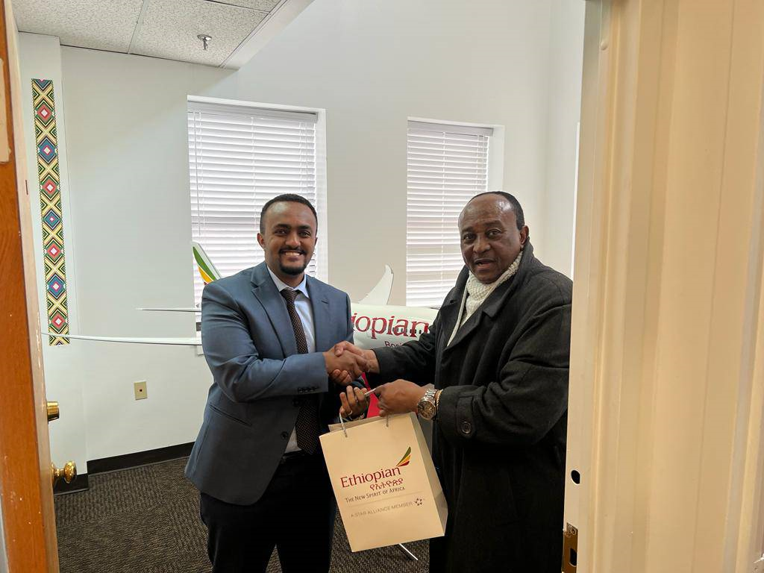

NEW SPONSORSHIP OPPORTUNITIES

Pan-African Quarterly Report

Our Pan-African Quarterly Report is the cornerstone of our commitment to delivering high-quality content to our audience. This report encapsulates the most insightful, and compelling top stories from the Pan-African world, providing readers with a comprehensive and in-depth analysis of key events and developments.

Highlights:

- Compelling Content: The Pan-African Quarterly Report is meticulously curated to highlight the most significant and thought-provoking stories impacting the Pan-African world. We delve deep into issues that matter, offering fresh perspectives and incisive analysis.

- Insights: We tackle insightful topics, sparking conversations and shedding light on pressing issues that demand attention. Our dedication to honest and unbiased reporting sets us apart.

- Digital Excellence: The digital edition of our Pan-African Quarterly Report is a testament to our commitment to providing accessible and engaging content. It has garnered a substantial following and is downloaded by a vast and diverse audience across the globe.

- Global Reach: Our digital edition is not bound by geographical constraints. It reaches readers from all corners of the world, making it a truly global resource for anyone interested in the Pan-African world. Targets 12 million reach.

Audience Engagement:

- Impressive Downloads: The digital edition of our Pan-African Quarterly Report consistently achieves a high number of downloads, reflecting its popularity among a discerning and informed readership.

- Shareability: Our report's engaging and thought-provoking content is widely shared across social media platforms and beyond, amplifying its impact and reach.

Why Choose Our Pan-African Quarterly Report Report:

Our pan-African quarterly Report is more than just a collection of stories; it's a testament to our dedication to quality journalism and our mission to inform, engage, and inspire. By including our report in your media initiatives, you tap into a valuable resource that resonates with a global pan-audience and offers unique insights into the Pan-African world's top stories.

For more information on sponsorship, please contact us at marketing@theafricantimes.com.

